**SENG 696 Project Idea**

**COVID-19 Alarm System**

**Group I**

**System background and goal**

* The idea of this system was motivated by the COVID-19 pandemic. The whole world has been suffering from this virus for 9 months. It is quite difficult to control the spread due to the infectiousness of the disease, and people are not aware of danger when they are close to a high-risk area since they don’t have access to the latest information. Therefore, a system is to be set up to establish the interaction between residents, the government health service department and labs so that the alarm information could be sent to everyone timely. As a result, people could reduce the exposure to risky neighborhoods and lower the possibility of getting infected.

**System description**

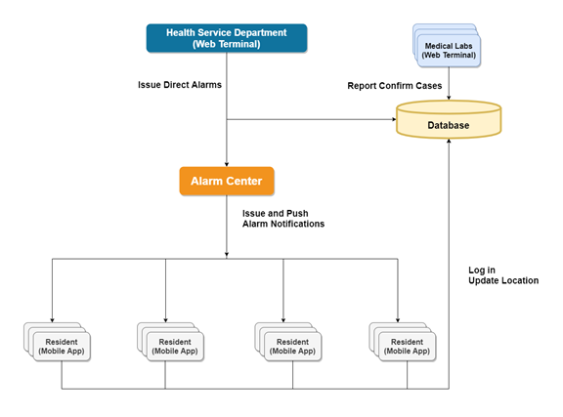

Assumptions

* Information of Residents (Name, health card number, community, date of birth, etc.) and Officer/Doctor/Physician users (Name, registration id, position, etc.) are provided by the Health Service Department.
* Residents are supposed to install the app on their mobile phones and authorize the permission to acquire location and push notification.

**Requirements**

* Resident users should log in directly with their names and health card numbers. No registration required.
* Resident users can update location with the mobile app. Location information of resident users updates every 5 minutes.
* Physician users from labs can update confirmed cases.
* Officer users from the health service department can issue direct alarm to all users.
* Alarm center scans the main database and automatically issue alarm to:
  + All residents who live in the community where confirmed cases currently live.
  + All residents who stay in the area within 100 meters from confirmed cases.

**Wish List**

* Expand the database so that the alarm could be applicable to other contagious diseases.
* Officer/Doctor/Physician users (for the health service department, hospitals, clinics, labs) should log in with usernames and passwords. Registration is required with validation.
* Resident users can update personal symptom status with the mobile app.
* Doctor/Physician users from hospital/clinics can update residents’ personal symptom status.
* Alarm is also issued to all residents who live in the community where more than 10 people report symptoms.

**Database Structure**

|  |  |  |  |  |  |
| --- | --- | --- | --- | --- | --- |
| Table: Residents Information (Main Table) | | | | | |
| **Key** | **HCID** | **NAME** | **COMM** | **LOC** | **STAT** |
| **Value definition** | Health Card No  (Primary Key) | Resident’s’ legal name | Current living community name | Current Latitude and longitude | 0=healthy  1=confirmed |
| **Data type** | int | Str | Str | float,  2x1 matrix | int |